Innovative Sensors Transforming Agriculture: A Deep Dive
Welcome to the forefront of agricultural technology! Sensors are not just tools—they’re the backbone of modern farming, driving precision and efficiency. Let's explore these technological marvels in greater detail.

1. Soil Moisture Sensors: The Water Guardians
Soil moisture sensors act as the vigilant guardians of soil health, ensuring crops get just the right amount of water. Here’s an in-depth look at the various types:
- Capacitive Sensors: Measure the dielectric constant of soil, which varies with moisture content. They’re accurate and less affected by soil salinity, making them ideal for diverse soil types.
- Resistive Sensors: Utilize electrical resistance between two probes. As moisture increases, the soil’s electrical conductivity improves, providing a direct measure of moisture levels. They are generally cost-effective but can be affected by soil salinity and temperature.
- Frequency Domain Sensors: Employ electromagnetic waves to assess moisture levels based on signal frequency changes. They offer high precision and are less susceptible to soil salinity.
- Tensiometers: Measure soil tension or suction, indicating how hard plants need to work to extract water from the soil. They’re useful for understanding soil water availability in more detail.
- Time Domain Reflectometry (TDR): Uses the time it takes for an electromagnetic pulse to travel through the soil to measure moisture content. TDR provides highly accurate readings and is suitable for research and precision agriculture.
With real-time data from these sensors, farmers can optimize irrigation systems, conserve water, and improve crop yields while reducing wastage and costs.
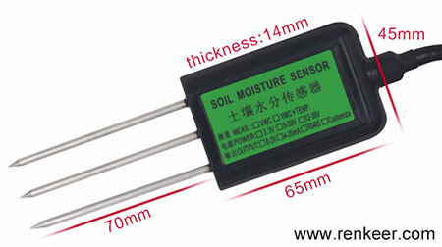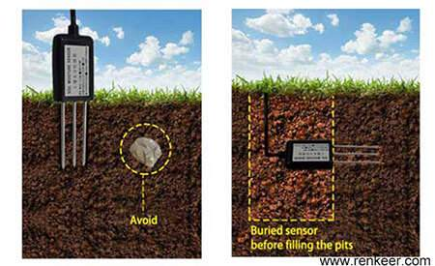
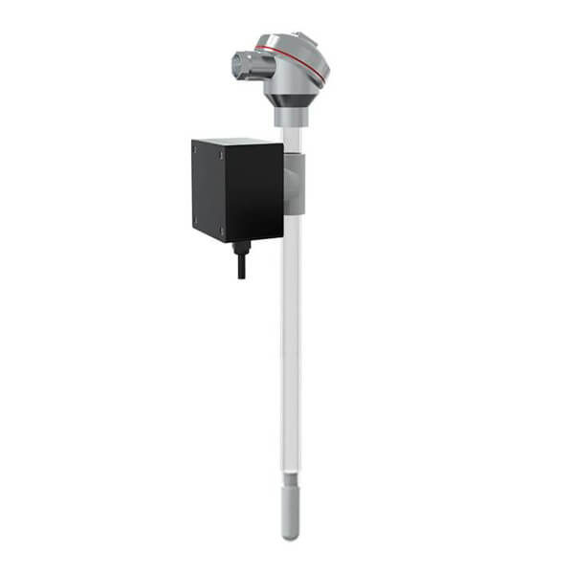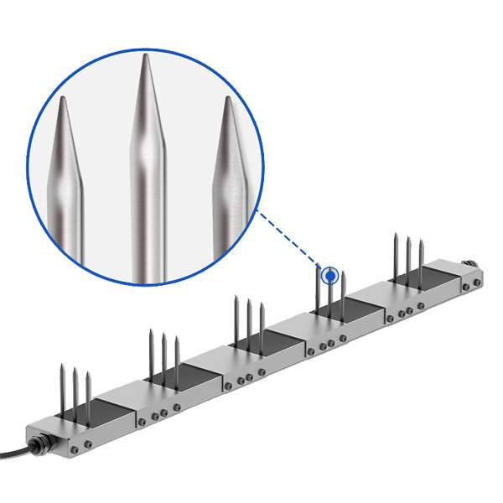
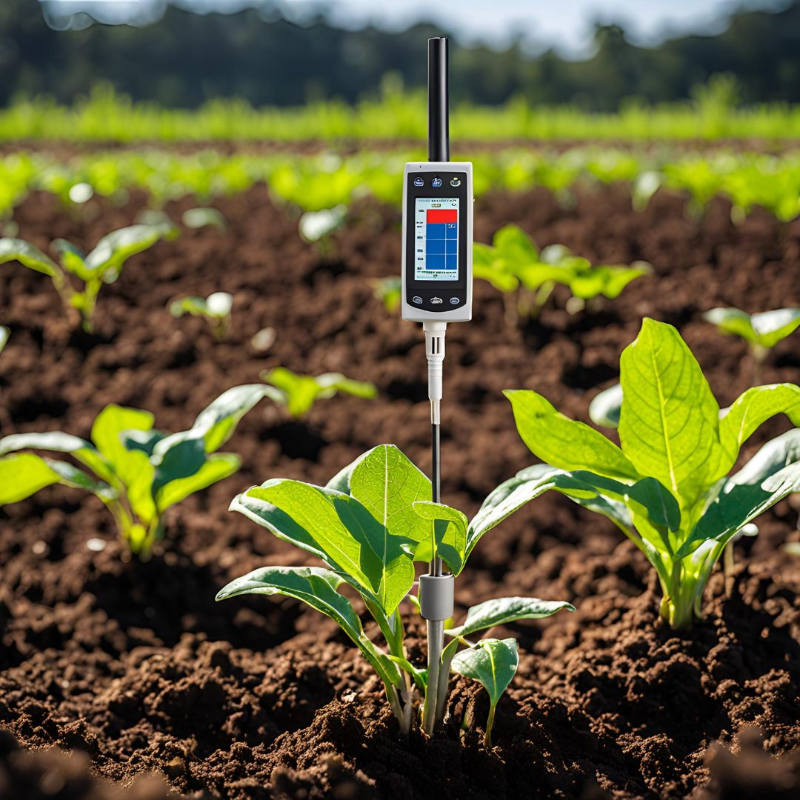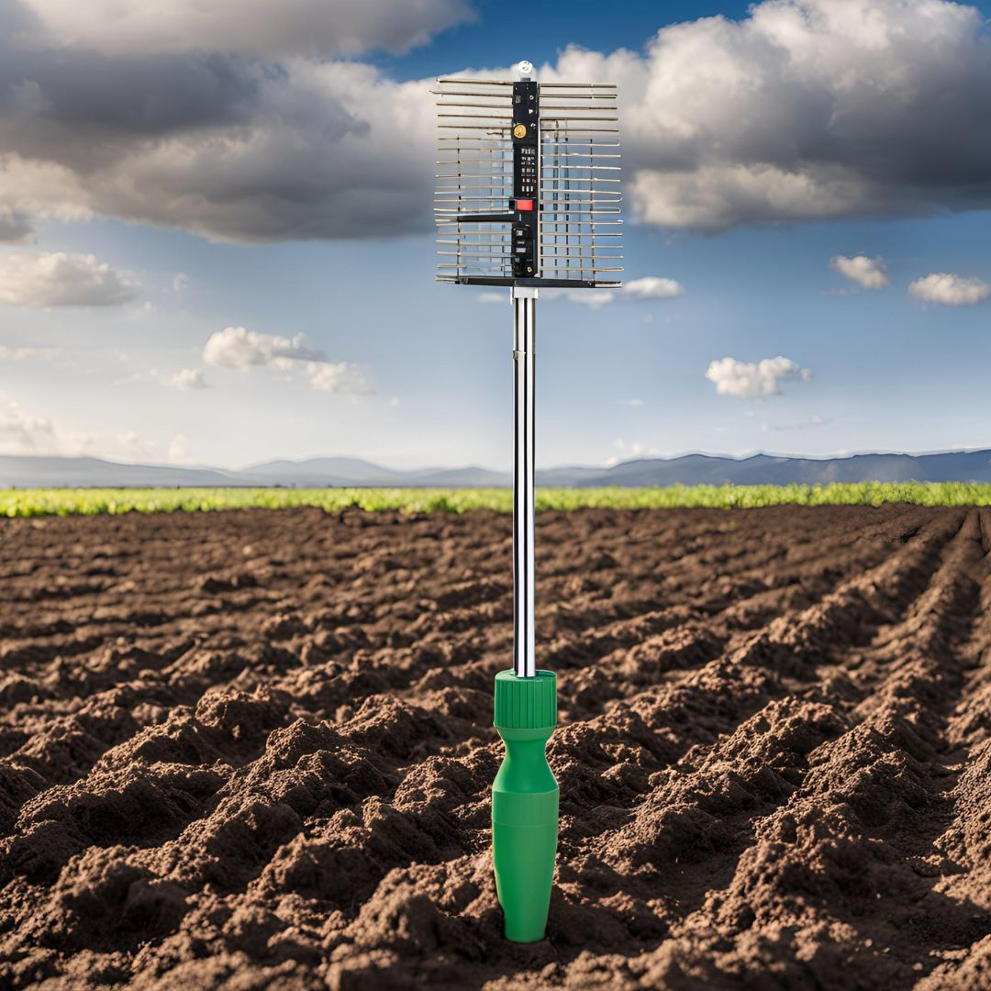

2. Soil Temperature Sensors: The Crop Thermometers
Soil temperature sensors are crucial for maintaining optimal growing conditions. Here’s a closer look:
- Thermocouples: Generate a voltage proportional to temperature, suitable for a wide range of temperatures and environments.
- Thermistors: Utilize materials with resistance changes that correspond to temperature variations. They offer high accuracy and rapid response times.
- RTDs (Resistance Temperature Detectors): Measure temperature based on the resistance of metals, typically platinum. They are highly accurate and stable over a broad temperature range.
- Soil Infrared Thermometers: Use infrared technology to measure soil surface temperature remotely, offering non-contact measurements.
- Optical Fiber Temperature Sensors: Provide continuous and high-resolution temperature monitoring through fiber optics, ideal for detailed analysis in various soil layers.
By monitoring soil temperature, these sensors help farmers manage planting times, forecast frost events, and adjust practices to enhance crop growth and productivity.
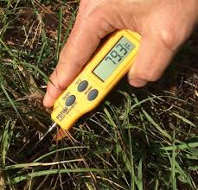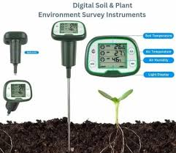
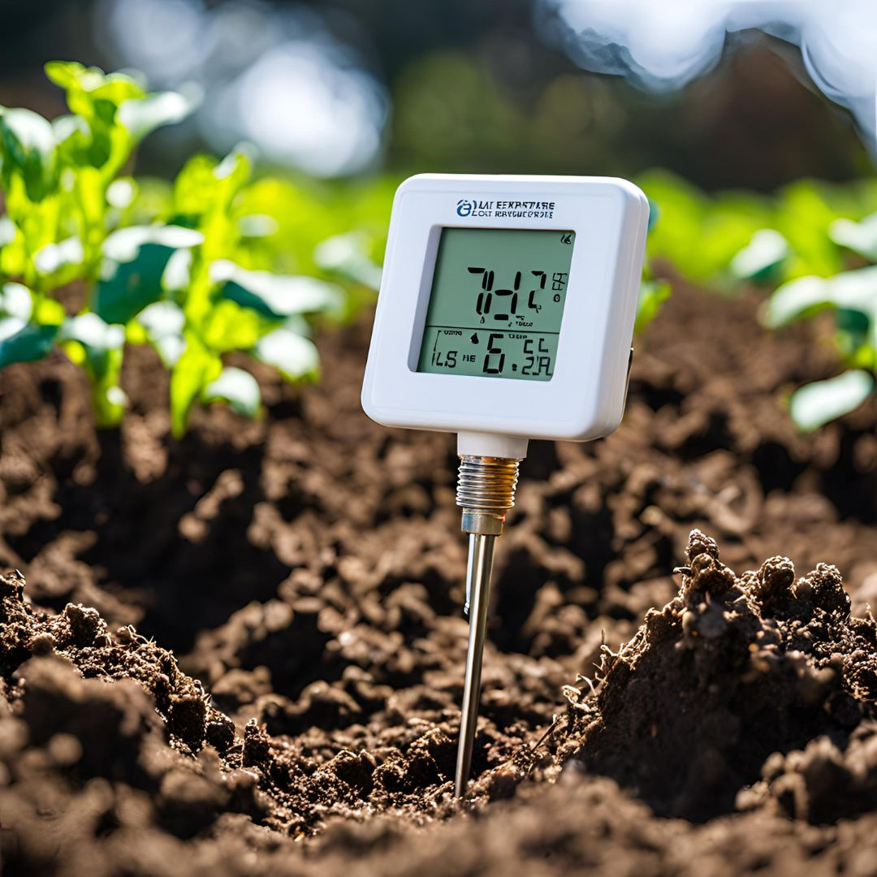

3. Leaf Wetness Sensors: The Leaf Detectives
Leaf wetness sensors are the detectives of the plant world, monitoring moisture levels on leaves to predict diseases. Here’s how they work:
- Capacitive Sensors: Measure changes in capacitance due to water on leaves, offering a direct measure of wetness. They are durable and provide reliable data in various conditions.
- Resistive Sensors: Detect changes in electrical resistance caused by moisture. They are cost-effective and widely used but can be affected by surface deposits and contamination.
- Optical Sensors: Use light reflection or transmission to determine leaf wetness. These sensors can be highly sensitive and accurate, providing detailed data on moisture levels.
- Fiber Optic Sensors: Employ fiber optics to measure the amount of moisture on leaves, offering precise and continuous monitoring with minimal interference.
- Conductivity Sensors: Measure changes in electrical conductivity on the leaf surface to assess wetness. They are particularly useful for detecting early signs of disease.
These sensors are essential for managing plant health, enabling timely interventions with fungicides and pesticides, and improving overall crop yield and quality.
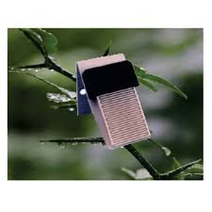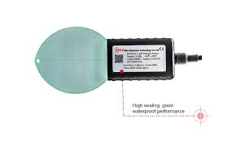

4. Weather Stations: The Climate Connoisseurs
Weather stations are the climate connoisseurs of agriculture, providing comprehensive environmental data. Here’s a detailed look at their components:
- Thermometers: Measure air temperature, crucial for predicting weather patterns and managing planting schedules.
- Hygrometers: Assess humidity levels, which influence plant transpiration and disease development.
- Barometers: Track atmospheric pressure, aiding in weather forecasting and understanding weather changes.
- Anemometers: Measure wind speed and direction, helping to prevent wind damage and plan field operations.
- Rain Gauges: Record precipitation levels, crucial for managing irrigation and assessing water availability.
- Solar Radiation Sensors: Measure the amount of solar radiation reaching the plants, helping to estimate photosynthesis rates and crop growth.
- Evapotranspiration Sensors: Estimate the rate of water loss from soil and plants, aiding in precise irrigation management.
By integrating data from these sensors, farmers can make informed decisions about irrigation, planting, and harvesting, ultimately enhancing productivity and sustainability.

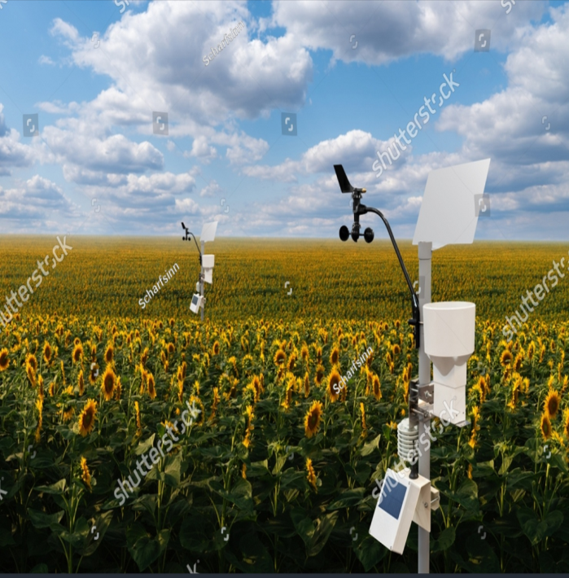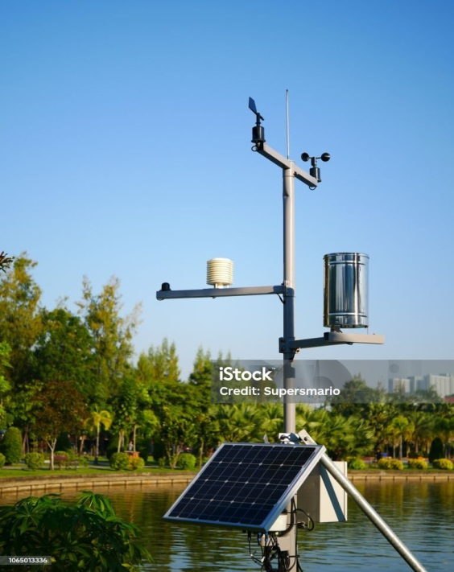
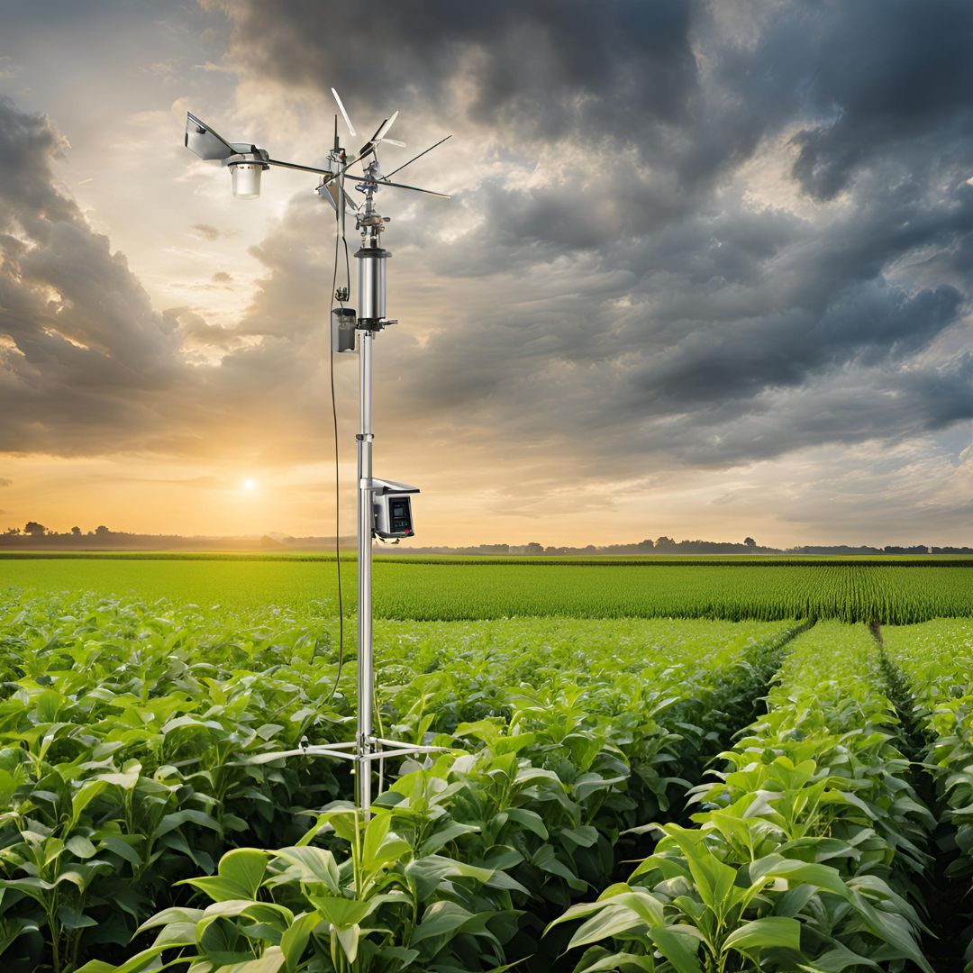

5. Nutrient Sensors: The Soil’s Nutrient Analysts
Nutrient sensors are the soil’s nutrient analysts, providing crucial data for soil management. Here’s an expanded view:
- Ion-Selective Electrodes: Measure the concentration of specific ions (e.g., nitrate, potassium) based on changes in electrode potential. They offer targeted analysis of nutrient levels.
- Optical Sensors: Use light absorption or fluorescence to detect nutrient concentrations, offering real-time, accurate measurements.
- Electrochemical Sensors: Employ redox reactions to determine nutrient levels, suitable for continuous monitoring and precise nutrient management.
- Colorimetric Sensors: Utilize chemical reactions that produce a color change proportional to nutrient concentration, providing a simple and effective measurement method.
- Capacitance Sensors: Measure the dielectric constant of the soil to estimate nutrient levels indirectly, often used in combination with other sensors for comprehensive analysis.
These sensors enable precise nutrient application, enhance soil health, and improve crop yield by ensuring optimal nutrient availability.
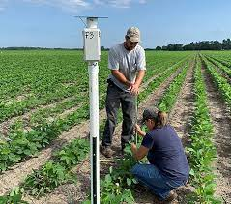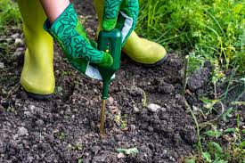
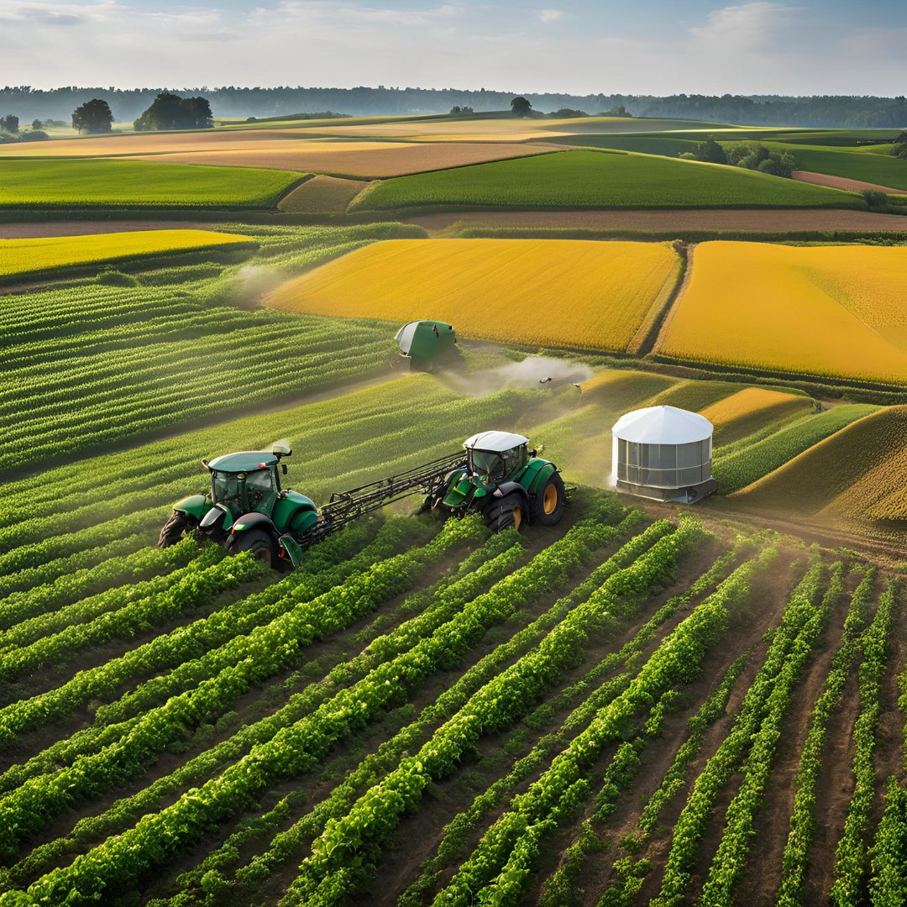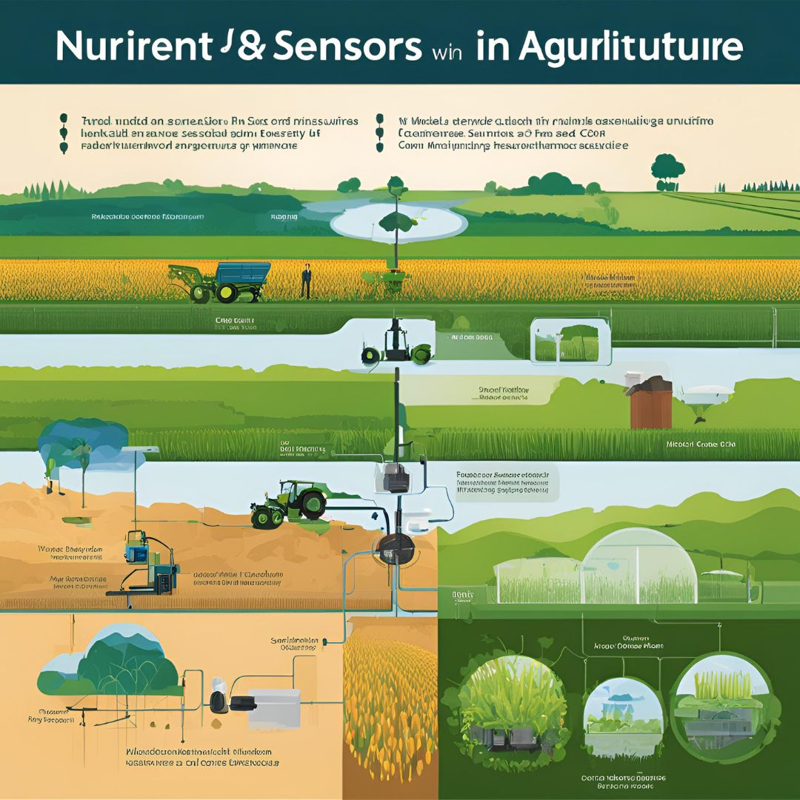

6. Optical Sensors (Spectrometers): The Plant Health Scanners
Optical sensors, or spectrometers, are the plant health scanners of the future, offering detailed insights into plant conditions. Here’s a breakdown:
- Reflectance Spectrometers: Measure light reflected off plant surfaces to assess health and stress. They are commonly used in precision agriculture to monitor plant conditions.
- Transmittance Spectrometers: Analyze light passing through plant material, useful for detecting internal plant issues and assessing crop quality.
- Hyperspectral Imaging: Captures a wide range of wavelengths to provide detailed information about plant health, stress levels, and nutrient deficiencies.
- Multispectral Imaging: Uses multiple bands of light to evaluate plant health and monitor growth stages, helping in early disease detection and yield prediction.
- Near-Infrared (NIR) Sensors: Measure light in the near-infrared spectrum to assess plant water content, biomass, and other physiological parameters.
These sensors enable early detection of issues, optimize crop management, and enhance yield prediction.
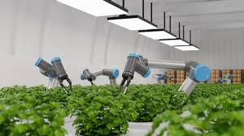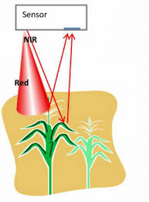
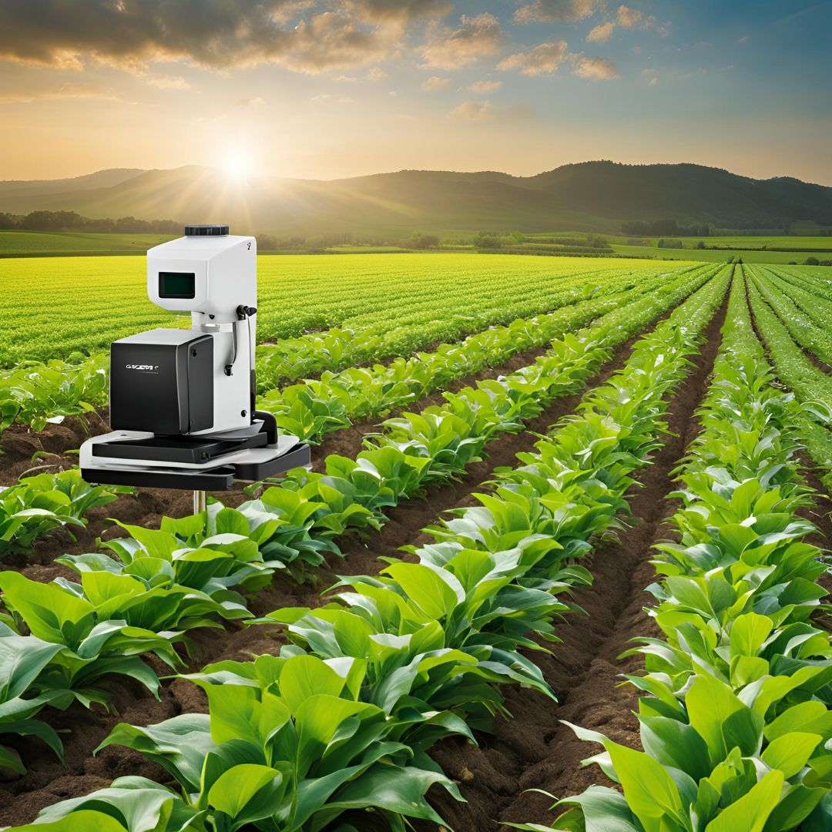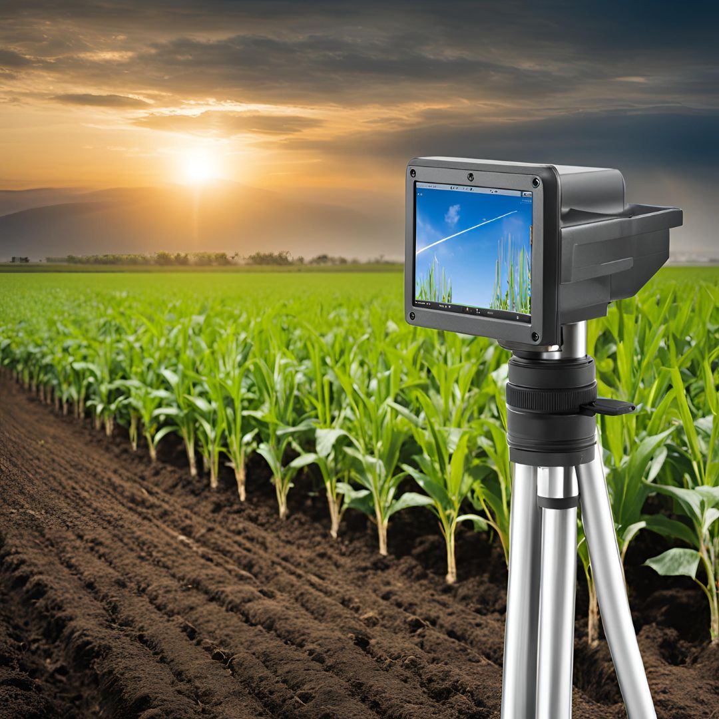

7. Remote Sensing Sensors: The Aerial Eyes
Remote sensing sensors offer a bird’s-eye view of agricultural fields, providing valuable data from above. Here’s a closer look:
- Multispectral Sensors: Capture data across various wavelengths to assess crop health, soil conditions, and vegetation indices like NDVI (Normalized Difference Vegetation Index).
- Hyperspectral Sensors: Provide detailed spectral information across a wide range of wavelengths, allowing for precise identification of plant species, health conditions, and soil properties.
- LiDAR Sensors: Use laser pulses to create high-resolution 3D maps of terrain and crop canopies, aiding in terrain analysis, canopy structure assessment, and biomass estimation.
- Thermal Imaging Sensors: Measure the heat emitted by plants and soil, providing insights into water stress and crop health.
- SAR (Synthetic Aperture Radar): Captures data through clouds and at night, useful for monitoring soil moisture and crop conditions in all weather conditions.
These sensors enable large-scale monitoring, detailed analysis, and timely intervention, enhancing precision agriculture and overall farm management.
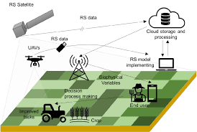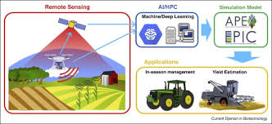
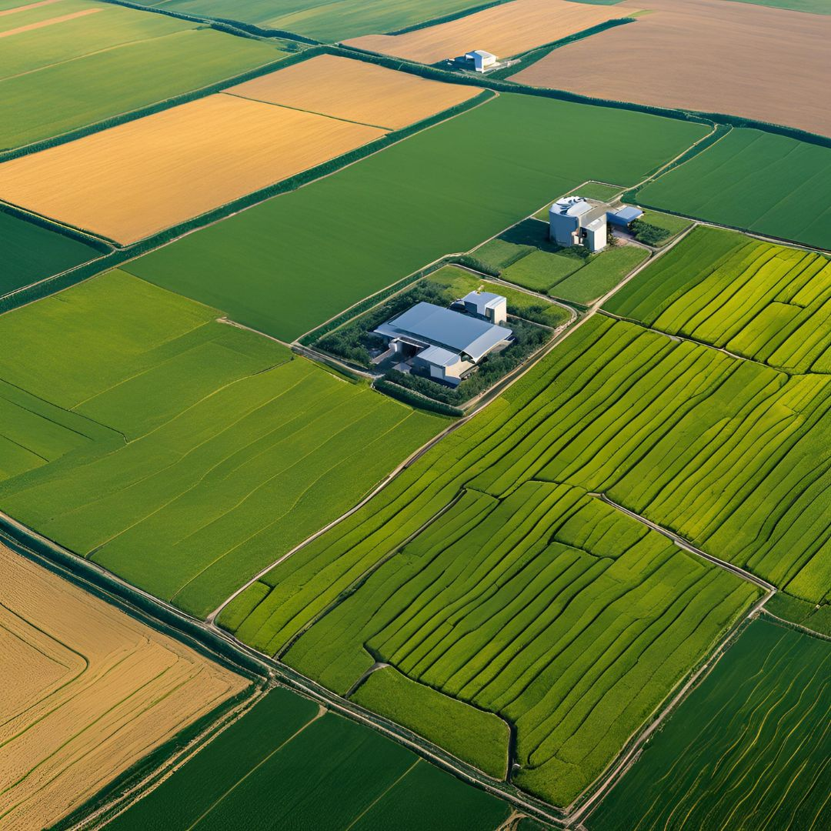

Conclusion
As we embrace these advanced sensors, we step into a new era of agriculture where technology and nature harmoniously work together. These sensors offer invaluable insights, driving efficiency and sustainability while helping farmers make informed decisions for a prosperous and resilient future. Welcome to the age of smart farming!

The Marvels of Electronic Sensors: Unveiling the Secrets of Nutrient Detection
Welcome to a journey through the cutting-edge world of electronic sensors! Imagine sensors as the superheroes of modern agriculture, each with unique powers to monitor and manage nutrients. Let's meet these high-tech heroes and see how they’re transforming farming.

1. Potentiometric Sensors: The Voltage Virtuosos
Meet the Potentiometric Sensors, the maestros of electrical potential. Picture them as musicians who detect the subtle changes in voltage to unveil the secrets of nutrient concentrations.
- Their Superpower: Measuring electrical potential to reveal the levels of specific ions in the soil or nutrient solutions. They’re adept at detecting ions like nitrate and potassium, making them invaluable for soil testing and hydroponics.
- How They Work: Equipped with a reference electrode and an indicator electrode, they compare the voltage difference to a standard calibration curve, translating it into nutrient concentration.
- In Action: Imagine a soil scientist using these sensors to fine-tune irrigation systems, ensuring crops get just the right amount of essential nutrients.
Image:

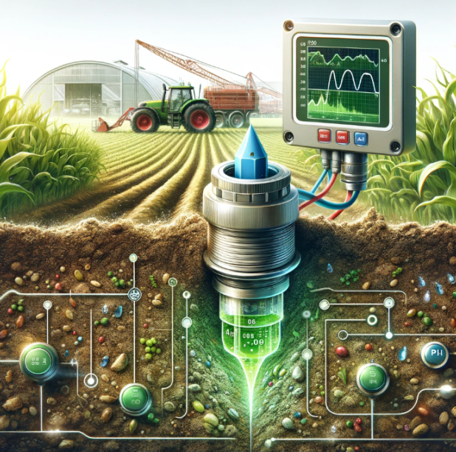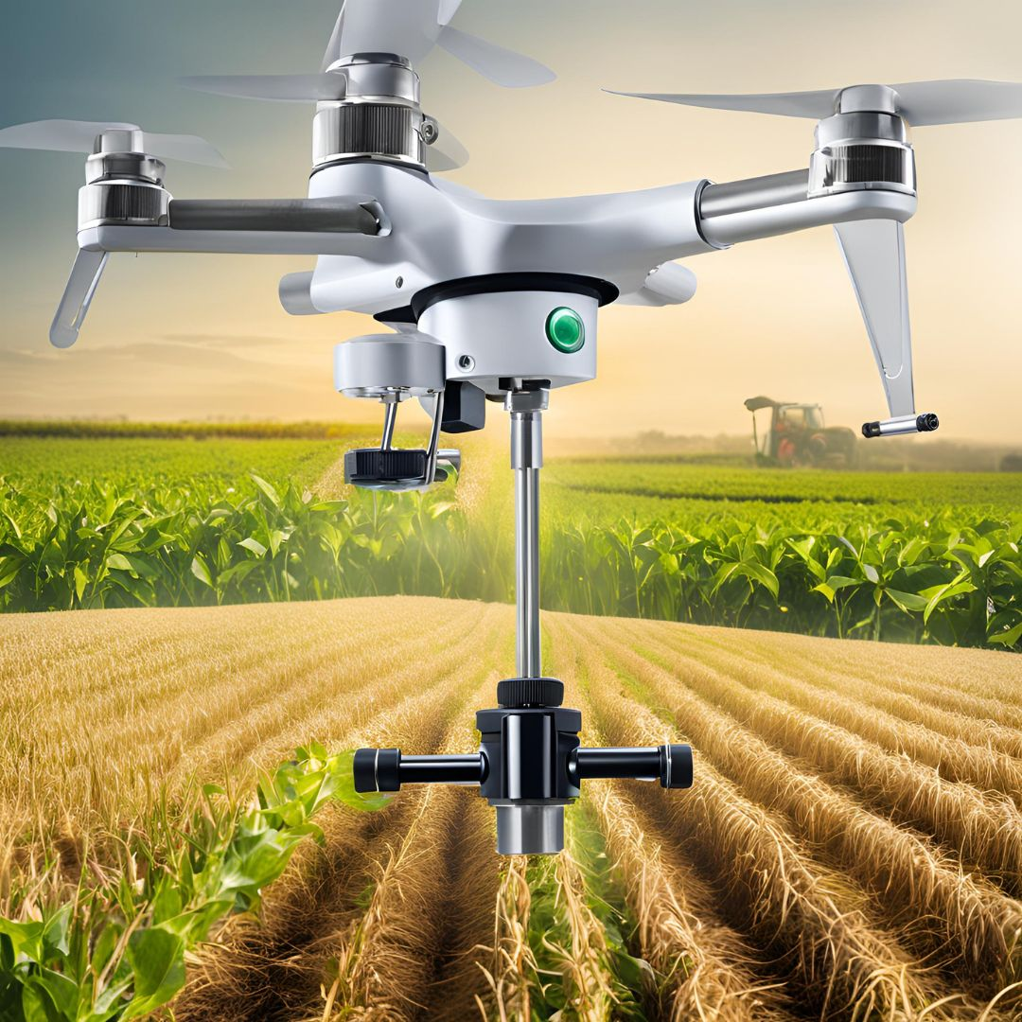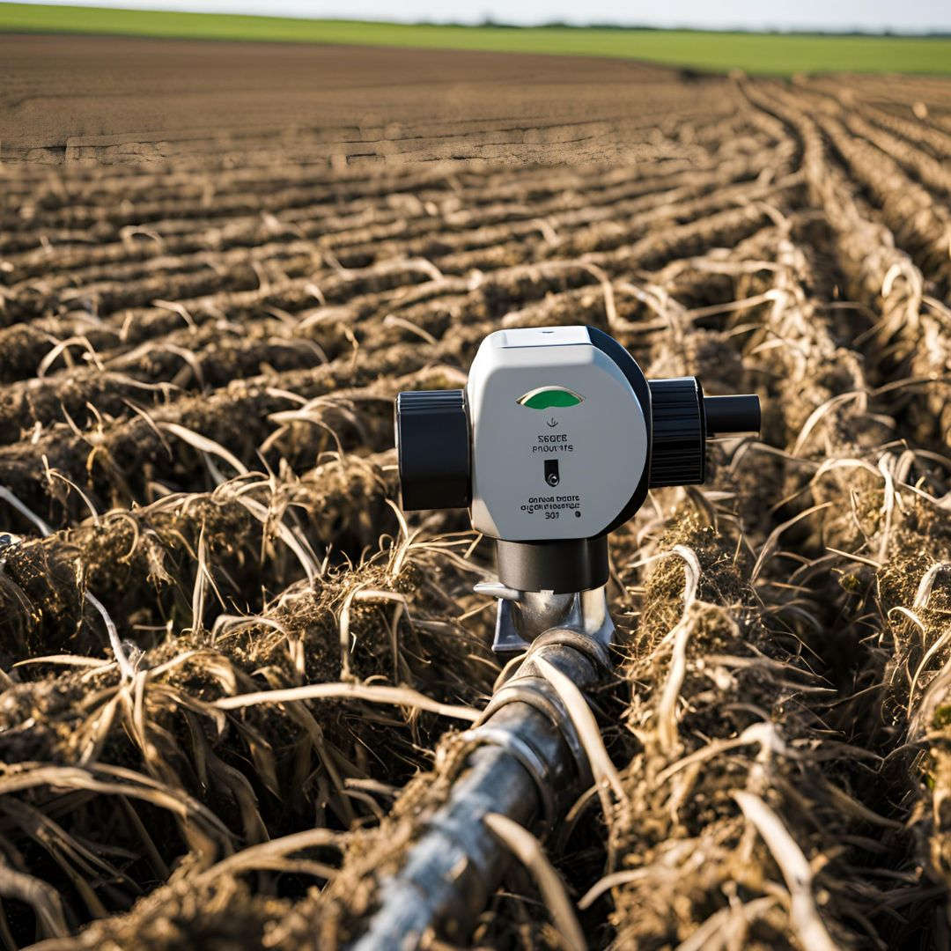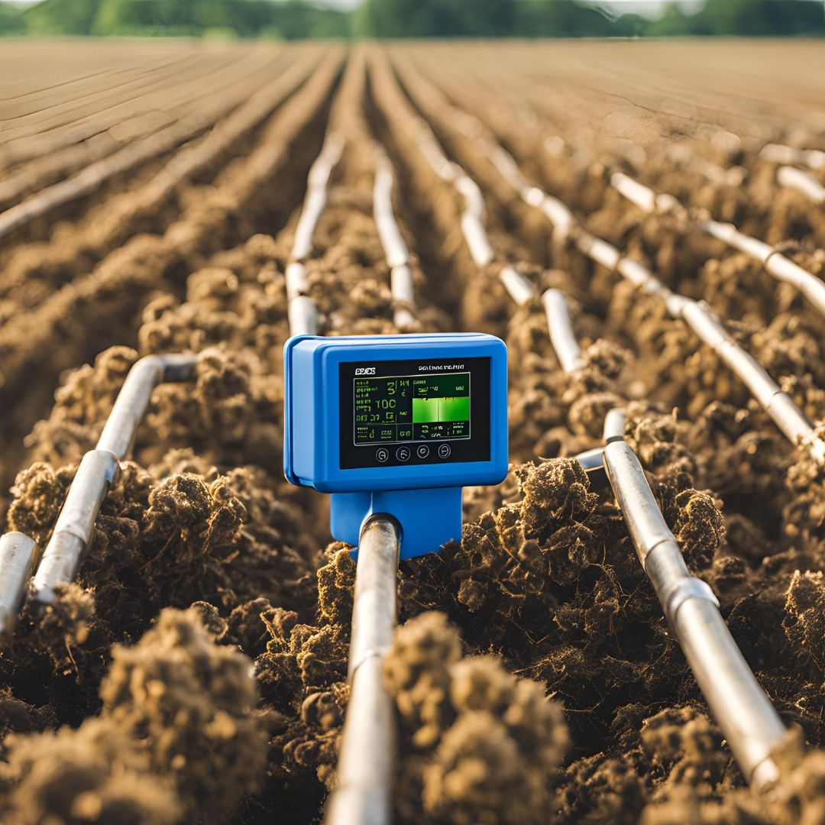

2. Voltammetric Sensors: The Current Connoisseurs
Next, we have the Voltammetric Sensors, the current connoisseurs who dance to the rhythm of electrical currents.
- Their Superpower: They analyze the relationship between applied voltage and resulting current to identify nutrient levels. Their specialty lies in detecting trace elements with remarkable sensitivity.
- How They Work: By applying varying voltages to an electrode and measuring the resulting current, these sensors use techniques like cyclic voltammetry to provide detailed nutrient profiles.
- In Action: Imagine these sensors as part of a lab setup, uncovering the hidden concentrations of nutrients in fertilizers and environmental samples.
Image:
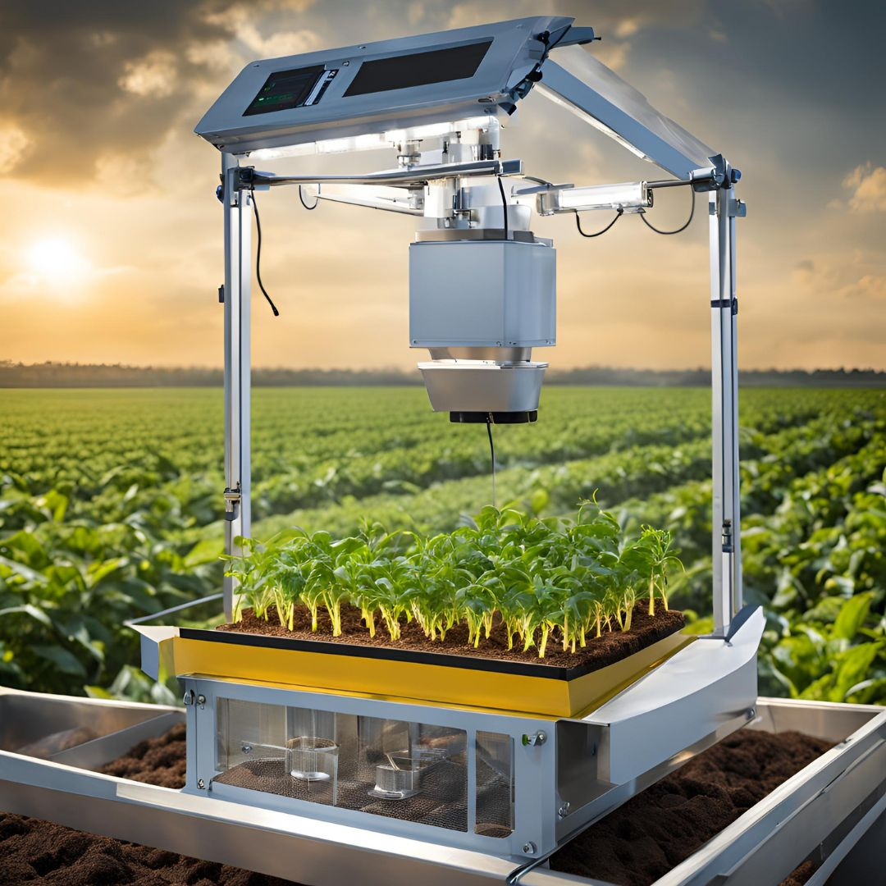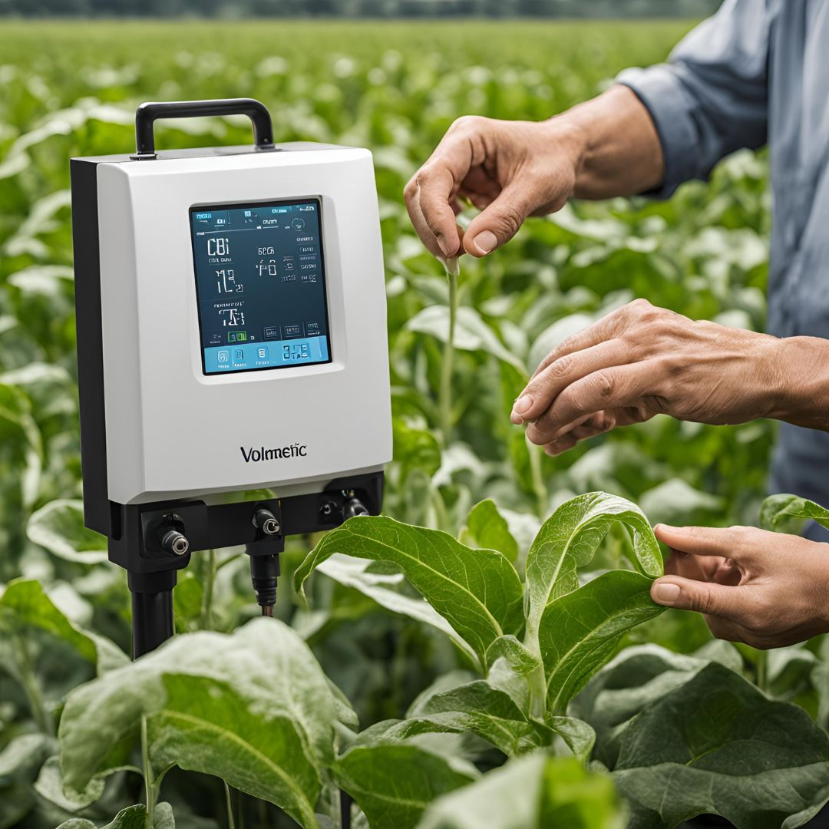

3. Field-Effect Transistor (FET) Sensors: The Voltage Regulators
Enter the Field-Effect Transistor (FET) Sensors, the voltage regulators with a keen sense for electrical changes.
- Their Superpower: Using transistor technology, they detect changes in ion concentrations by altering the electrical properties of the transistor. Perfect for real-time nutrient monitoring.
- How They Work: When specific ions interact with the gate electrode, they change the transistor’s voltage and current flow. This change is directly proportional to the nutrient concentration.
- In Action: Picture these sensors deployed in a high-tech greenhouse, continuously tracking nutrient levels and optimizing plant growth in real time.
Image:
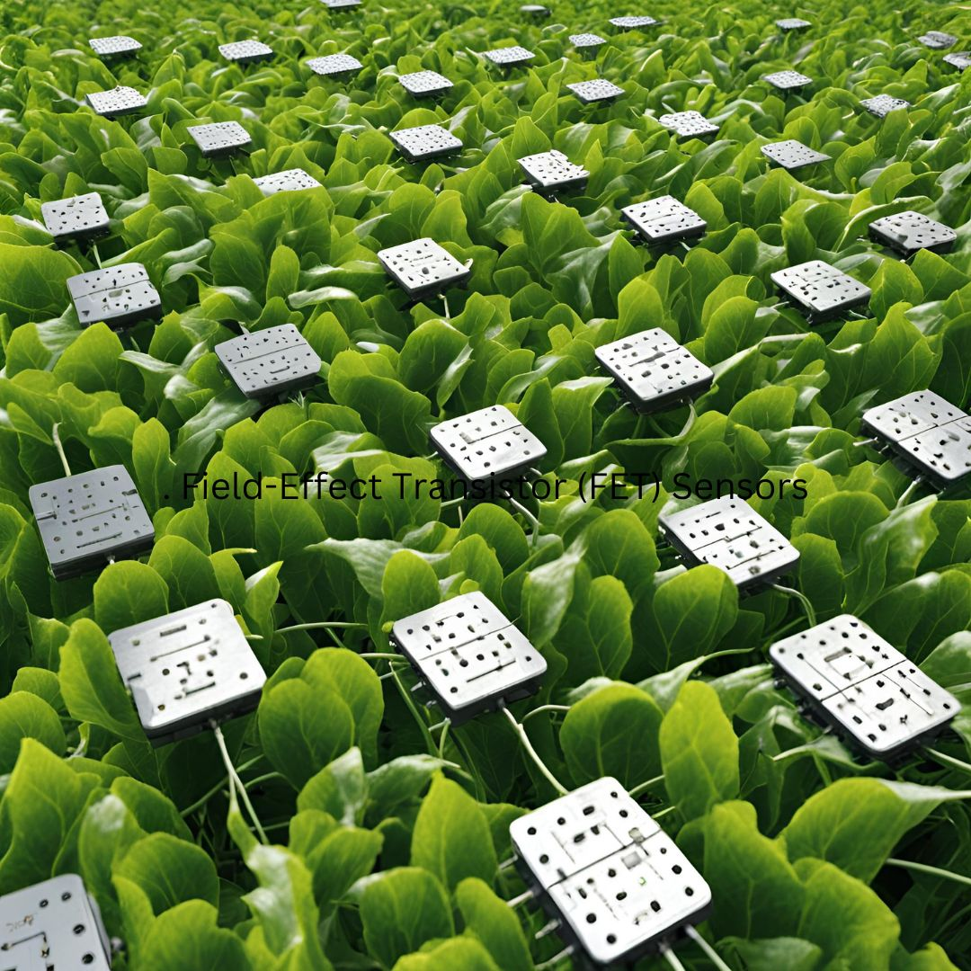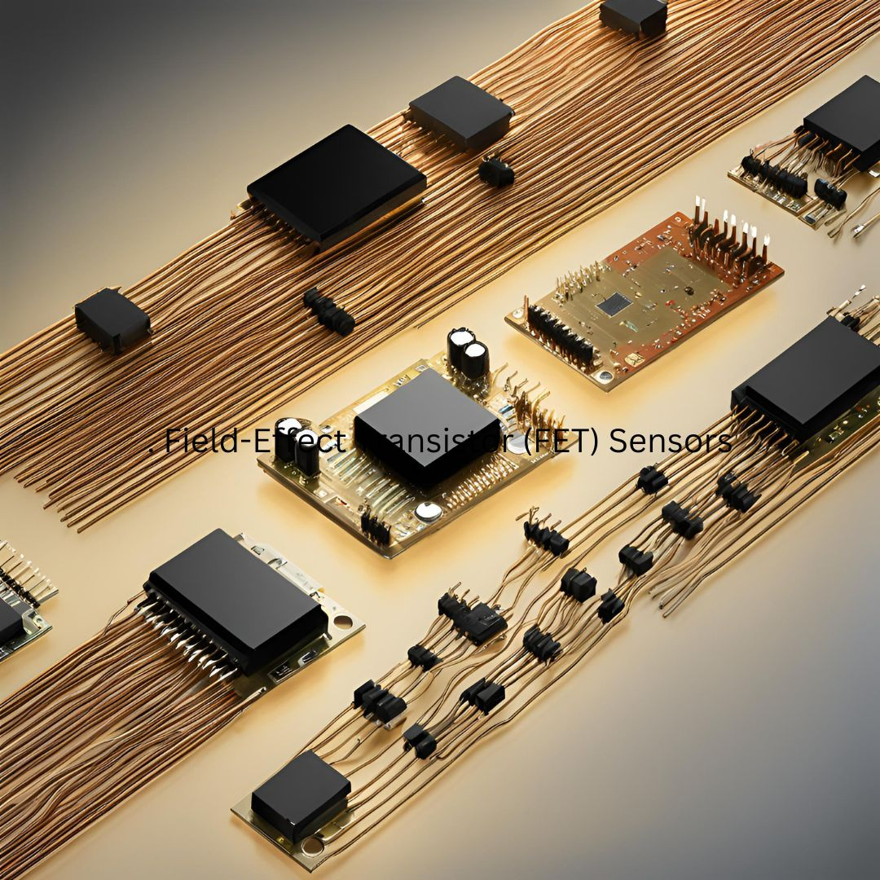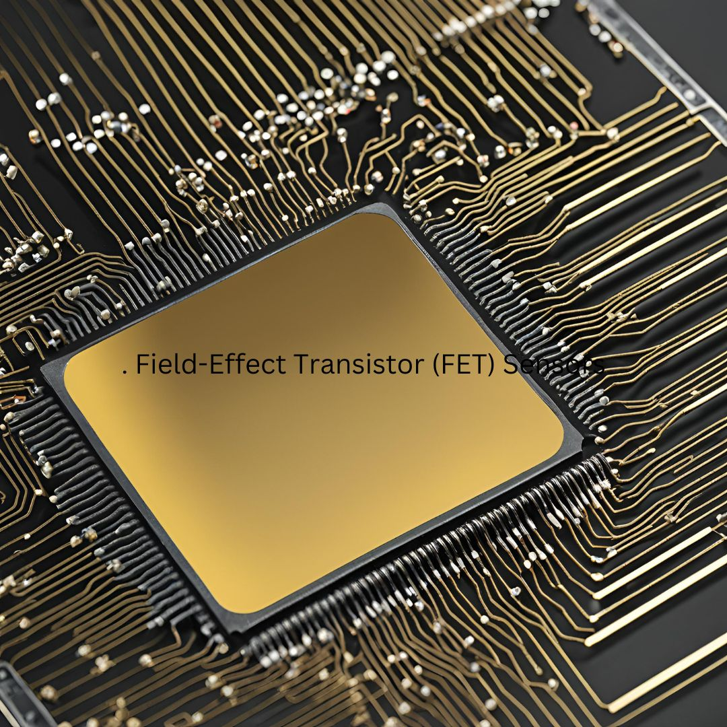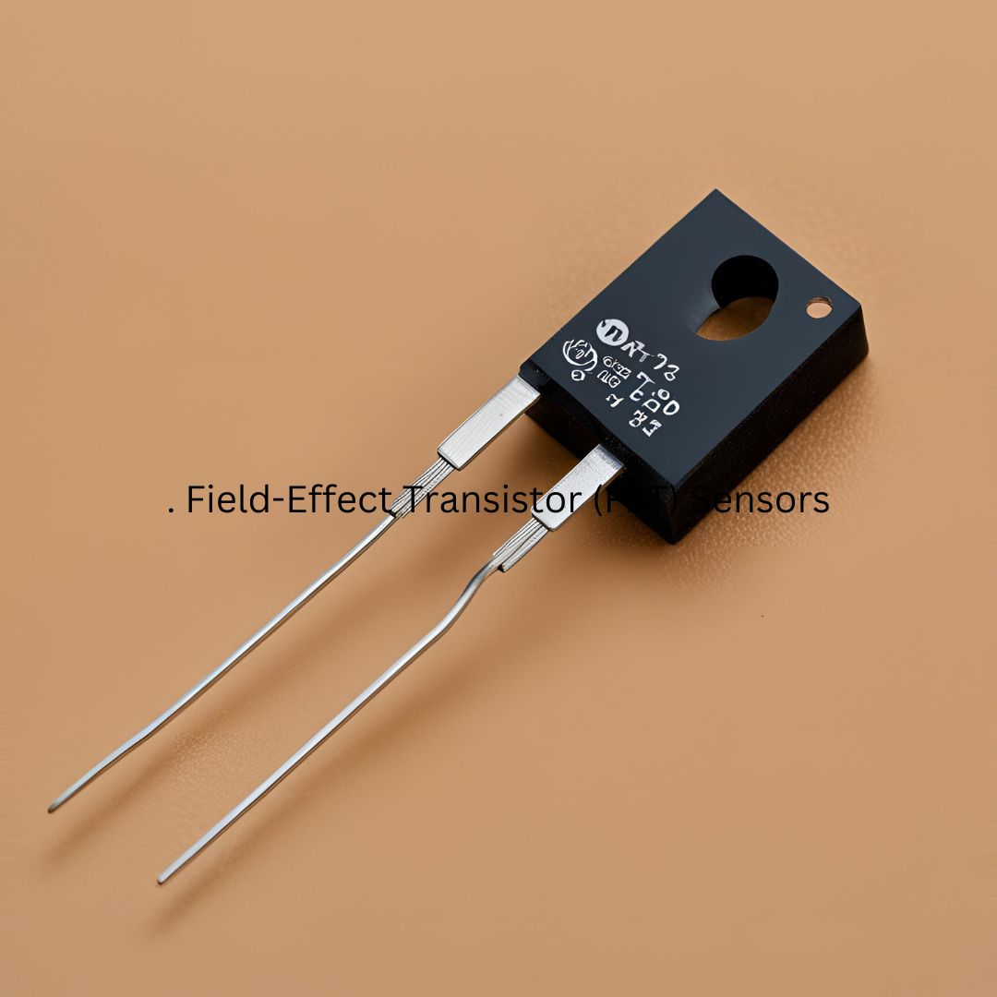

4. Ion-Selective Electrodes (ISEs): The Precision Detectives
Meet the Ion-Selective Electrodes (ISEs), the precision detectives of nutrient analysis.
- Their Superpower: They selectively measure the concentration of specific ions by responding to changes in electrical potential. Their accuracy makes them indispensable in soil and water testing.
- How They Work: Consisting of a specialized membrane, they interact with target ions to produce a voltage response. This voltage indicates the concentration of the ions in the sample.
- In Action: Visualize a farmer using ISEs to ensure that the soil has the right amount of nutrients for optimal crop health.
Image:
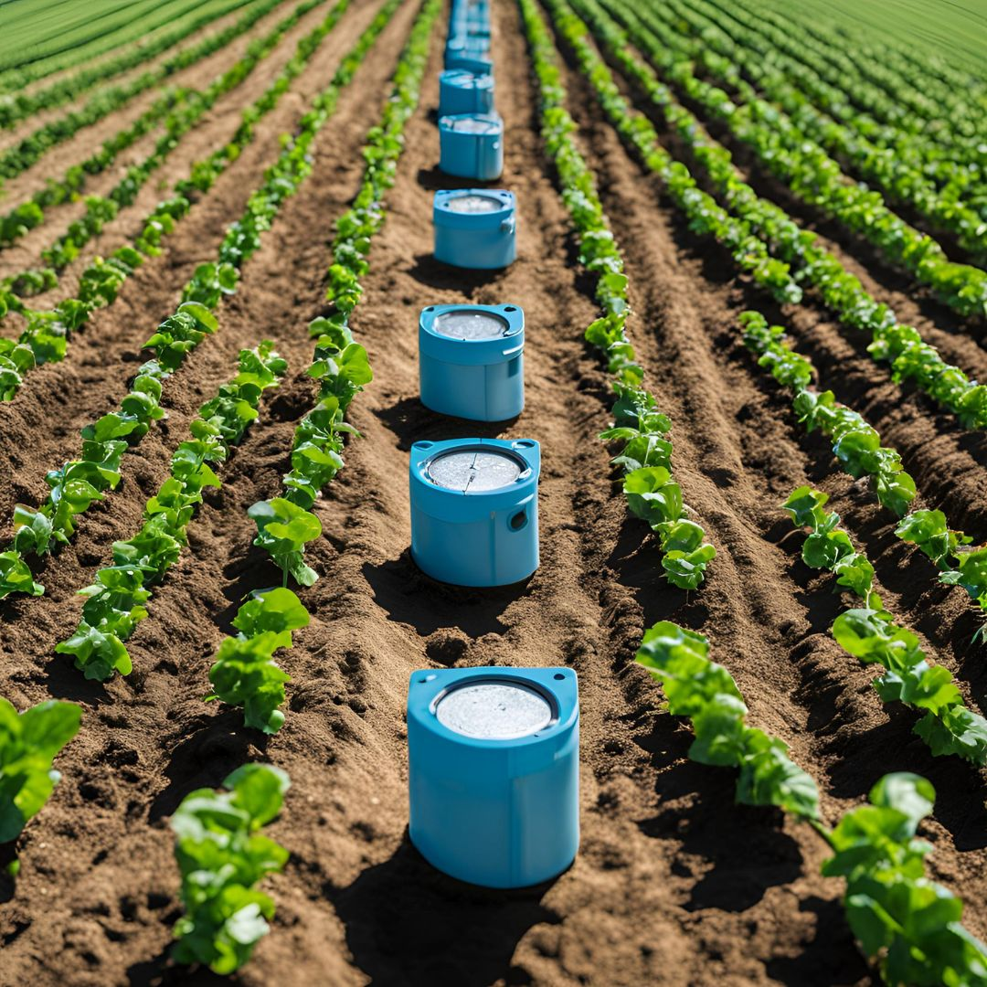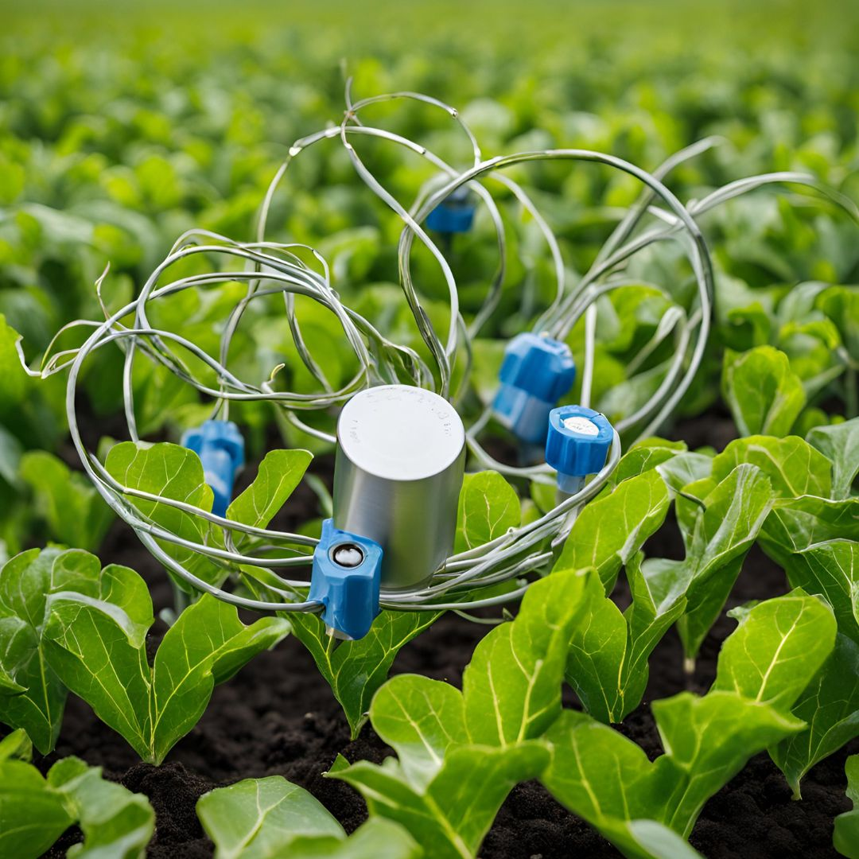

5. Optical Fiber Sensors: The Light Sleuths
Introducing the Optical Fiber Sensors, the light sleuths who uncover nutrient secrets through light.
- Their Superpower: They measure nutrient concentrations by detecting changes in light properties such as absorption or fluorescence. They excel in providing continuous and accurate readings.
- How They Work: Light passes through or reflects off a sample, and changes in light intensity or color reveal the nutrient concentrations.
- In Action: Imagine these sensors embedded in a hydroponic system, continuously monitoring nutrient levels and ensuring plants receive exactly what they need.
Image:
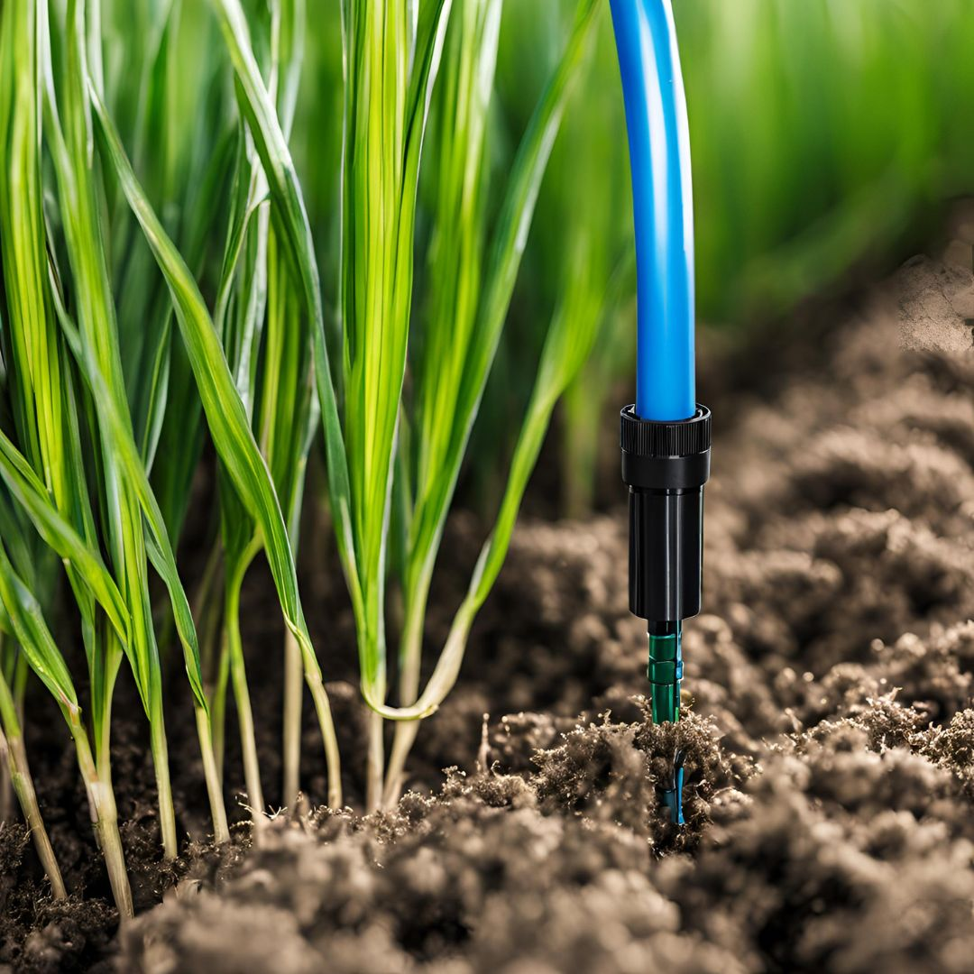

6. Colorimetric Sensors: The Color Chameleons
Meet the Colorimetric Sensors, the color chameleons who detect nutrients by changing hues.
- Their Superpower: They use chemical reactions that produce color changes proportional to nutrient concentrations. Their ability to provide quick and visual results makes them user-friendly.
- How They Work: By mixing a sample with a reagent, the resulting color change is measured. The intensity of the color correlates with the nutrient concentration.
- In Action: Picture these sensors being used in field kits, allowing farmers to quickly test soil or water samples and make on-the-spot decisions.
Image:
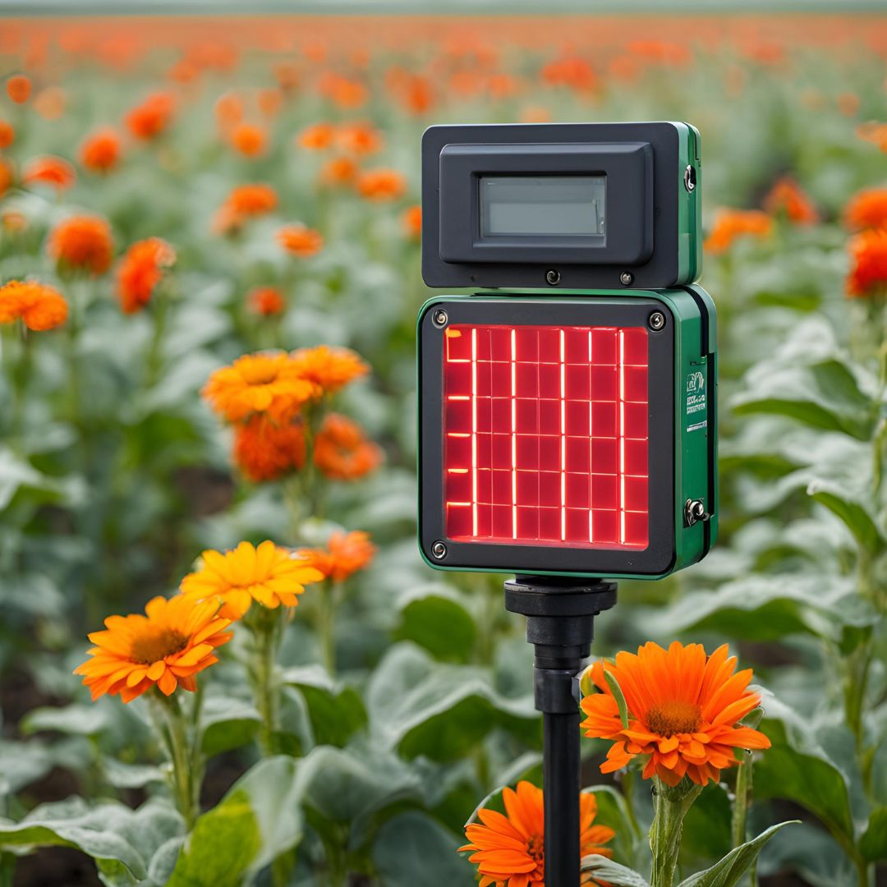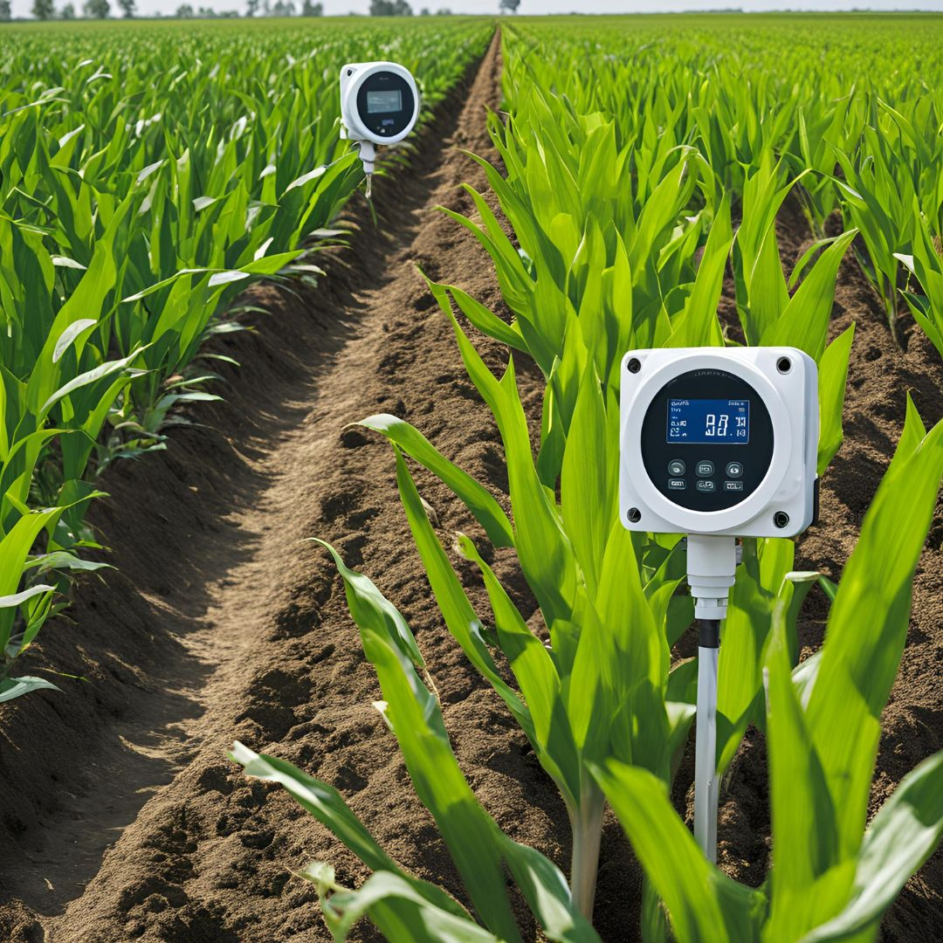

7. Conductivity Sensors: The Salinity Sentries
Finally, let’s meet the Conductivity Sensors, the salinity sentries who gauge nutrient levels based on electrical conductivity.
- Their Superpower: They measure the ability of a solution to conduct electricity, which is directly related to the concentration of dissolved salts and nutrients.
- How They Work: By measuring the electrical conductivity of a sample, these sensors provide an indirect estimate of nutrient levels.
- In Action: Imagine these sensors being used to monitor soil salinity and nutrient levels in an irrigation system, ensuring crops get the right balance of nutrients.
Image:
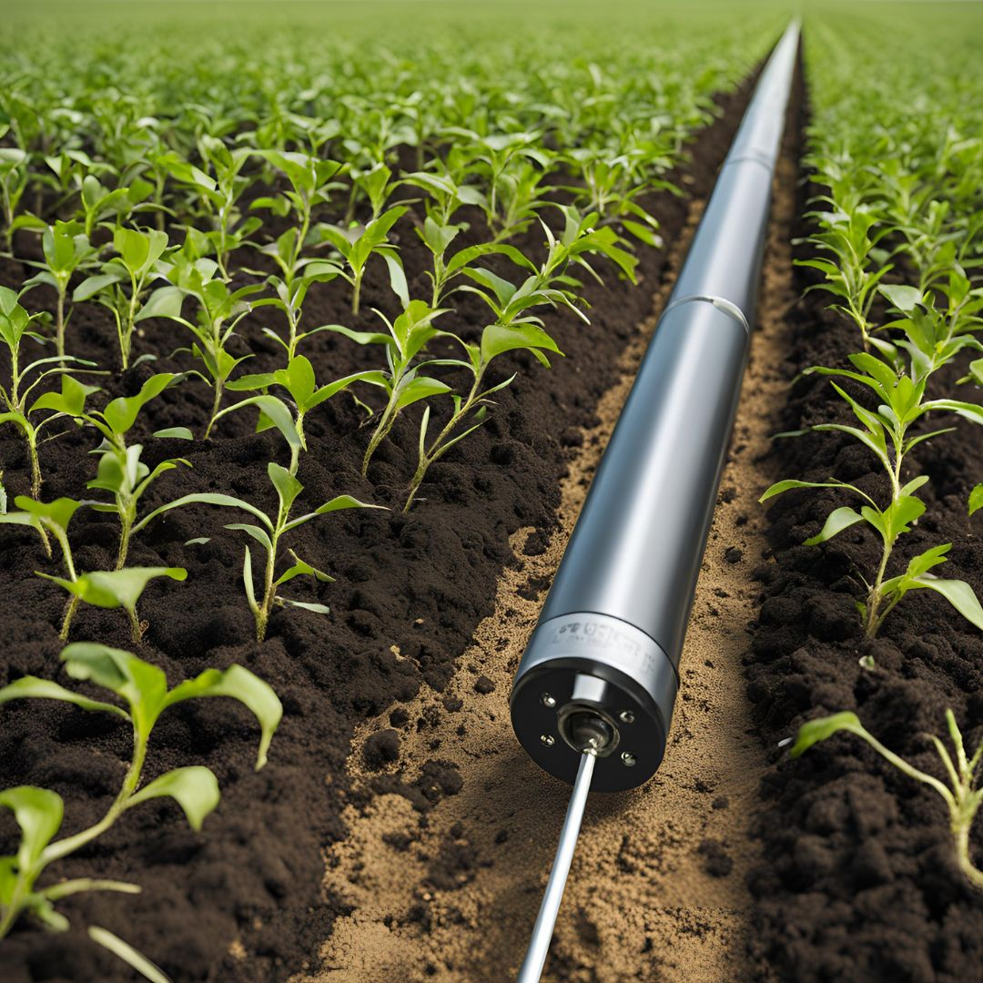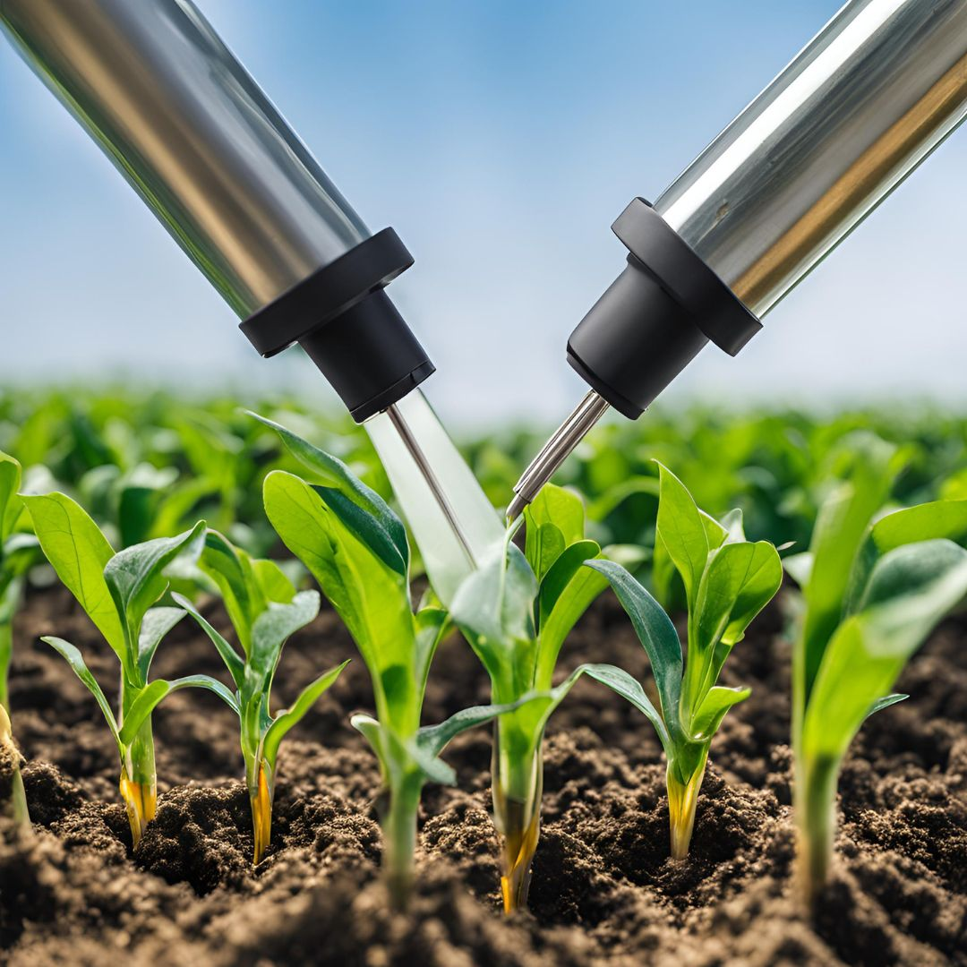

Conclusion
These electronic sensors are the unsung heroes of modern agriculture, each bringing their unique abilities to the table. From detecting electrical changes to analyzing light and color, they empower farmers to make informed decisions, optimize nutrient use, and boost crop productivity. In the world of smart farming, these sensors are not just tools—they’re the guardians of a thriving, sustainable future.

